Chapter 7

CROP AND FERTILIZER RECOMMENDATION SYSTEM USING MACHINE LEARNING

Radha Govindwar¹, Shruti Jawale¹, Tanmayee Kalpande¹, Sejal Zade¹, Mr. Pravin Futane², Idongesit Williams ³
¹Student, Vishwakarma Institute of Information Technology, Pune, Maharashtra, India - 411048, sejal.21910689@viit.ac.in
¹Student, Vishwakarma Institute of Information Technology, Pune, Maharashtra, India - 411048, radha.21910261@viit.ac.in
¹Student, Vishwakarma Institute of Information Technology, Pune, Maharashtra, India - 411048, shruti.21910863@viit.ac.in
¹Student, Vishwakarma Institute of Information Technology, Pune, Maharashtra, India - 411048, tanmayee.21911189@viit.ac.in
²Professor, Vishwakarma Institute of Information Technology, Pune, Maharashtra, India - 411048, pravin.futane@viit.ac.in
³CMI, Alborg University, Copenhagen, idong@es.aau.dk

Abstract
Soil and fertilizers are an integral part of the yield to be harvested since the right type of soil and fertilizers in accurate amounts can enhance both the growth and health of the crops to a substantial extent. However, the present-day system does not comprehend the ingenious recommendations, but the nescience experimentation and legacy knowledge that extracts additional money and time from the farmers. Hence, a system that is both effective and user-friendly should be adopted. This paper proposes and implements an equivalent system to predict suitable crops and fertilizers according to geographical location and soil quality by applying machine learning algorithms. The proposed system mainly comprises four stages: Analysing and Visualising the data, Separating the data into training and testing sets, Training the machine learning models, and finally, Comparing the accuracy of each model. XGBoost and Random forest were the two models that were the most accurate when it came to determining the most efficient recommendation model. The highest accuracy was found out to be 99.31% for crops and 90% for fertilizers, making the system extremely valuable for the farmers to amplify their yield.

Keywords: Agriculture, Yield Prediction, Machine learning, XGBoost, Random Forest, Soil Nutrients.

1.1 Introduction
The agricultural sector is a major pillar of the Indian economy and contributes significantly to the economy each year. A sector that has such a significant contribution to the economy faces many problems each year resulting in a low yield of crops and farmers’ debts. One of the reasons for the low production in agriculture is imprecise and incorrect farming practices.
A general crop is grown through an area regardless of the soil quality. This practice avoids the need for special care and attention to the soil. A good yield can be determined by analyzing the factors that caused it. However, it is not possible to know the exact reasons for a bad yield if no analysis is made. This makes it harder to know the reasons for a bad yield. This abets debt and financial losses to the cultivators.
Machine learning has enabled us to analyze large amounts of data and draw observations from it. The paper proposes a crop and fertilizer recommendation system to overcome the aforementioned drawbacks. The proposed system aims to analyse entered soil data and recommend the most suitable crop and fertilizers for the concerned soil. The goal is to help the Indian cultivators to make an informed decision and maximize crop yields. The user has to enter the soil details for their farm viz. Nitrogen, Phosphorus, Potassium, temperature, humidity and moisture. Then the pre-trained machine learning model will recommend crops to the farmer. For fertilizer recommendation, all the aforementioned parameters, along with the crop to be planted, have to be entered. The pre-trained model will recommend fertilizer for the same. The system will be hosted as a website for ease of access to farmers.
Different approaches are used to build the proposed machine learning models. Random forest, Decision Trees, SVM, Gaussian naive Bayes and Xgboost were used and the best performing was finalized to be the recommendation model.
This system hopes to reduce the losses of farmers however, there are some drawbacks that could be solved further.

1.2 Literature Survey
India is a country dependent on agriculture. So, the better the crop yield, the better the production. Finding what crop is suitable for a particular land is usually passed down from generation to generation. But, when finding a technical solution, one comes across many solutions to one problem. Many articles with different methods to recommend crop and fertilizers came into consideration. (Fig 1.1) [1] A journal by the Turkish Journal of Computer and Mathematics Education on crop recommendation predicted with the help of ML and IOT (for soil parameters such as soil moisture, temperature, etc. Using sensors). Random forest and Naive Bayes Classifier algorithms were used in this experiment. The model actually shows an accuracy of 96.89%.
[2] Another paper on crop and fertilizer recommendation from the IRJET publication on a Support Vector Machine (SVM) algorithm model. The dataset has been acquired from the kaggle website including the required attributes. This project based on the SVM model gave an accuracy of over 90.01%. This system aims to help newcomers in this industry as well by taking into consideration climatic conditions.
[3] This paper presents an approach that uses the Internet of Things (IoT) and Machine Learning (ML) to develop a recommendation system for farmers. The system consists of four stages that start with soil analysis and end with recommendations. The prediction is carried out using the classification and clustering algorithm. They acquired two datasets: the crop requirement dataset and the fertilizer datasets. The performance analysis for nutrient analysis has an accuracy of 84.46% and a precision of 91.04%. The performance analysis for the recommendation system has an accuracy of 93.33%, a precision of 90.60%, recall of 90.00% and Fscore of 90.14%.
[4]This paper was presented in a book published by Progress in Advanced Computing. The paper presents an ontology-based system for recommending and assessing crop suitability. It uses Ontology to predict the crop's potential profitability and crop suitability based on the soil type and region.
Crop prediction is done using an algorithm called random forest, fertilizer recommendation is done through k-means algorithm. The crop data is acquired through the department of agriculture, Government of Maharashtra, which is stored in the form of ontology. The performance evaluation shows that the accuracy of the developed system is reasonably high.
[5] A paper published by IJESC proposes an efficient algorithm like Naive Bayes Algorithm for crop yield prediction and KNN algorithm for fertilizer prediction. The dataset has been acquired from the kaggle site for crop and fertilizer prediction. This project uses the data collected by soil analysis and KNN Classification algorithm to predict the optimal fertilizer ratio for a given crop. It then helps the end-user to make informed decisions about the fertilizer needed for that crop.
[6] Crop recommendation through city clever evaluation makes use of the crop and town dataset, the second module recommends crop for a selected soil nutrient values and the 1/3 module affords records approximately the soil nutrients which can be poor for a particular crop. The device uses datasets: crop dataset and soil dataset. The crop dataset includes the corresponding pH, N, P and K values of vegetation and the soil dataset consists of the corresponding pH, N, P and K for soils for various towns in Chennai and different districts of Tamil Nadu. The information are acquired from the Agriculture branch of Tamil Nadu in Kancheepuram district. The accuracy received as a result of using KNN algorithm became 89% and by means of using SVM algorithm turned into 80%. The accuracy is calculated primarily based on the effects acquired from check and teaching facts.
[7] Another such paper turned into JETIR Org. For crop prediction the use of records mining techniques. This structure is taken into consideration to expect the quality harvest suitable for the agronomists' region. It additionally indicates farming techniques for vegetation inclusive of various farming, spacing, irrigation, sow processing, and so forth. Along with facet fertilizer and pesticide proposals. This is executed on the premise of historic soil standards of the vicinity and estimating crop and climate fees. Further, cost prediction is carried out based totally on Linear Regression to resource in ranking the vegetation endorsed. The System Architecture of the trouble statements makes use of the following steps to decide the result which can be facts set series, feature selection, type techniques, advice system, crop yield prediction. Ensembling is a data mining model used to combine the strength of or extra fashions to acquire better predictability and efficiency than any of its fashions can reap on its own. The dataset includes particular soil features which are amassed for the Warangal check region in the soil test laboratory, Warangal, Telangana State, India. In addition, comparable online widespread crop data assets were also used. The application could be very pleasant and requires less memory.
[8] Lastly, from the European Journal of Molecular & Clinical Medicine, the proposed approach takes the soil and PH samples because the input and help to expect the vegetation that can be endorsed suitable for the soil and fertilizer that may be used as the solution in the form of the website. So, the soil data is gathered through sensors and the records transmitted from the Arduino with Zigbee and WSN (Wireless Sensor Network) to MATLAB and reading the soil statistics and processing is completed with help of ANN (Artificial Neural Network) and crop recommendation is carried out the usage of SVM (Support Vector Machine).For the dataset, standards like pH, nitrogen, potassium, phosphate, Depth, Temperature, Precipitation is received.

A detailed survey of the studied research papers (Fig 1.1)

Reference no. | Methodology | Dataset Details | Performance Measures | Result
1 | The real-time data from the field area is collected using the IoT system and fed to the trained model and predictions are made. Models used are Random Forest and Naive Bayes | Self-collected data. | accuracy of about 96.89%. is obtained | The system predicts and suggests the crops to be sown with an accuracy of about 96.89%.
2 | The data is being first cleaned and preprocessed and then the Support Vector Machine(SVM) algorithm is used. | Kaggle dataset Fertlizer_Recommendation 100 entries. kaggle dataset for crop recommendation 2000 entries | gives  the accuracy over 90.01%. | The Support Vector Machine algorithm helps to predict the crop with 90.1% accuracy
3 | The proposed methodology analyzes soil using Arduino and electrodes to gather data. This data is stored in the cloud and recommendation is done using machine learning techniques. | Columns (N, P, K soil type, region, variety, season, NPK ratio and total ppm value.). Entries>1000 | the system has an accuracy of 93.33%, | on giving crop to be aggregated, state and district, variety of the crop; season and soil type, recommendations are made with 93.3% accuracy
4 | an android application where prediction is done using random forest, fertilizer recommendation is done through the k-means algorithm. | acquired through the department of agriculture, Government of Maharashtra. | Accuracy of 92.14% for the entire system | Recommendations of crops and fertilizers were provided with 92.14% accuracy using random forests and KNN.
5 | The proposed work implements Naive Bayes Algorithm for Crop yield prediction and KNN Algorithm is used for Fertilizer Recommendation. | acquired from the kaggle site for crop and fertilizer prediction | Naive Bayes and KNN perform well. Accuracy per cent not mentioned | The recommendation system is made with Naive Bayes and KNN for Crop and fertilizer recommendation
6 | The proposed system uses the KNN algorithm for crop recommendation through city-wise analysis | obtained from the Agriculture department of Tamil Nadu in Kancheepuram district. | The accuracy for KNN was 89% and  SVM was 80% | KNN was found to provide the highest efficiency and precision compared to Decision tree, Random Forest etc. for crop datasets.
7 | The System Architecture proposes data set collection, feature selection, classification techniques, recommendation system, crop yield prediction. | Crop yield data sets are obtained from fao.org, soil data for Warangal test Area | not mentioned | This paper summarizes an  effective recommendation system for fertilizers and crops based on NPK values and the region.
8 | The soil information is collected through sensors, transmitted from the Arduino through Zigbee and WSN to MATLAB and processing is done with help of ANN and crop recommendations are done using SVM. | Self-collected dataset | not mentioned | SVM is used to predict crops and recommendations are displayed on web pages.

1.3 Proposed System
The proposed system aims to help the farmers cultivate suitable crops and fertilizers for their land according to their geographical location and soil quality. The data used for the recommendation system is a publicly available dataset that comprises unique attributes, such as NPK value, humidity, rainfall, temperature and pH of the soil.
The architecture of the system can be decomposed into several steps (Fig 1.2).

1] Import Libraries

Various libraries have been used to visualise, analyse and train the data for the machine learning models to work:
● Numpy
● Pandas
● Matplotlib
● Seaborn
● Scikit-learn

2] Data Analysis
After importing the libraries and gathering the dataset for the system, the data needs to be analysed in order to explore and find a pattern in the data. This enables us to find the necessary information and make decisions accordingly.
Several functions, such as df.head(), df.tail(), df.size(), can be used to analyse the data.

3] Visualise Data
Visualising data is an important aspect of machine learning as it allows the data to be represented as charts and graphs, allowing us to better understand and process the data. Data visualisation often helps to discover unknown facts and trends within the dataset. Thus, by observing the relationships and trends, one can acquire meaningful information.

4] Separate features and target label
We have to target an attribute in the chosen dataset to be used in the models. The rest are termed as features. The dataset then has to undergo a testing and training process, i.e., the dataset has to be divided into variables so as to pass them to the machine learning models for further functioning. This is achieved by train_test_split from scikit-learn to divide features data and target data.

5] Apply different models
After successfully separating features and targeting a label, the data is ready to be fed to the machine learning models for the training aspect. The proposed system trains decision tree, Gaussian Naive Bayes, Support Vector Machine, Logistic regression, Random forest and XGBoost. Sklearn helps to import these models in order to work upon them. Sklearn being an efficient python library also implements cross-validation and allows us to easily serialize and deserialize a trained model.

6] Compare accuracy and finalize a model
Finally, the accuracies of all the trained models are compared. The model with the higher accuracy is then finalized and used for the recommendation of crops and fertilizers based on the input.

7] Make a prediction
To confirm the working and accuracy of the finalized model, we can try to predict the output by giving the model some inputs to determine the recommended crop or fertilizer. A correct output confirms the accuracy of the model.

The architecture of the proposed system (Fig 1.2)
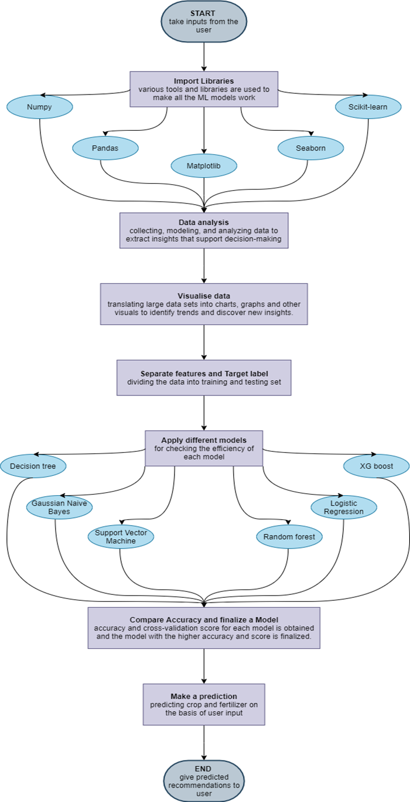

1.4 Implementation and Results
In crop recommendation, users have to give data from (like temperature, rainfall, N, P, K values) as input and the system will predict the crop they should grow.
In fertilizer recommendation, the users have to input soil data and the type of crop they are growing. The system then will predict what the soil lacks or has in excess and will suggest improvements.
We have used different models and have compared their accuracies. The model with the highest accuracy is chosen for the deployment.
The practical implication of this project will however be fulfilled with not a dataset from a kaggle site but from the real world dataset authorized by the government of India. Even the sensors will be needed to get the real time values from the farms and several other attributes including weather, temperature, etc. In a country like India, where farming has been going on for generations, there are several types of fertilizers including natural as well as artificial products, thus the most accurate and efficient in real world system will need the resources of all of them. Getting the highest accuracy for an efficient model is still a far fetched task yet to be accomplished.

1.4.1 Crop Recommendation Methodology:
- Data Analysis: We acquired a data set from kaggle which contains 2000+ entries. The dataset had the following columns: N, P, K, temperature, rainfall, humidity, Ph level of the soil and a crop label.
- The crop label was made the target variable, while all the remaining columns were determined as features.
- Data Visualization: we have figured out a heatmap for the features. It represents common and unique values while differentiating them with light to dark colours (Fig 1.3).
- Then we separated features and target variables to obtain training and testing datasets and applied different models to determine their accuracies. The most accurate model among them will be selected.
- Machine Learning models Decision Trees, Naive Bayes, SVM, Logistic Regression, Random Forests and XGBoost were trained using the dataset. The accuracies for each model were 90%, 99%, 10.6%, 95.22% , 99.09%, 99.31% respectively.

1.4.2 Fertilizer Recommendation Methodology:
- Dataset Acquisition: The dataset for fertilizer recommendation was obtained from kaggle. The dataset contains the following columns: temperature, humidity, moisture, NPK values and soil type. There are 100 entries in the fertilizer recommendation dataset.
- Dataset Preprocessing: The dataset was checked for null values or outliers. Categorical variables were encoded using

OneHotEncoder and Label Encoder. No null values were found. A large number of Potassium entries were 0, so they were omitted before feeding the data to models for reliability concerns.
- Proposed Algorithm: Observations were made by visualizing data. Different models (KNN, SVM, Random Forest, Decision Trees and Naive Bayes) are trained using the dataset, and the most accurate one is finalized. Currently, Random forest classification gives the highest accuracy of 90%. The other models used for this system: KNN, SVM, Naive Bayes classifier and the decision tree give accuracy of 75%, 55%, 50% and 85% respectively.

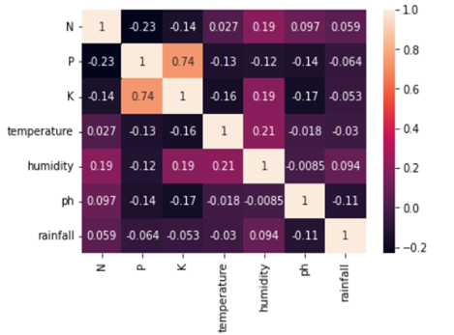
heatmap of crop dataset (Fig 1.3)

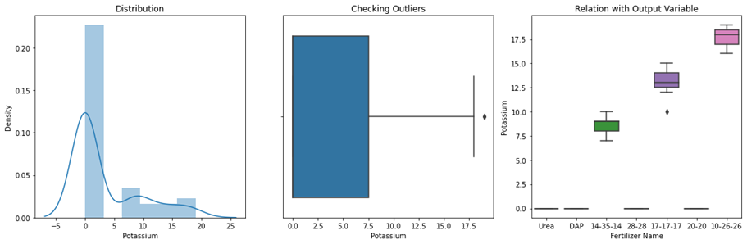
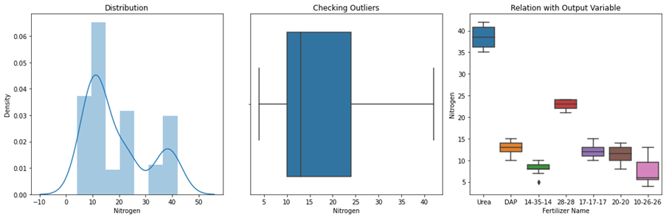
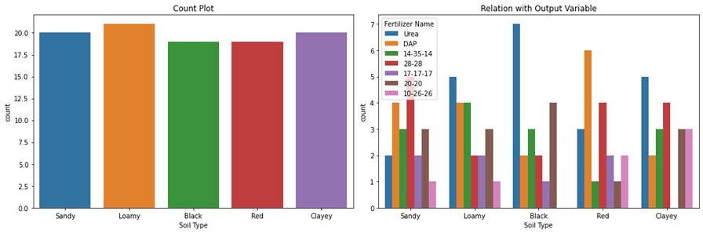
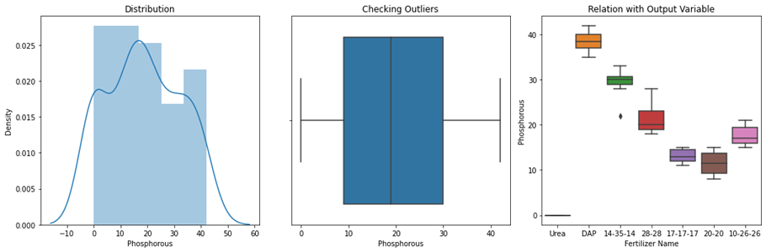
Data Visualization of fertilizer dataset (Fig 1.4)

1.5 Conclusion
This system is very promising for the farmers and newcomers in the long run if made into a user-friendly website or an application. It will assist farmers to choose the first-class crops appropriate for his or her land and appropriate fertilizers to provide the most yield in the agriculture enterprise, which in turn can assist the economy of the country. Thus, this will result in more earnings for those inside the agricultural area, and this reason will attract more people to contribute to this industry. This will also be helpful for the Agriculture Department of our country if given a chance to work on more real-world datasets.

References
[1] Anguraj.K, Thiyaneswaran.B, Megashree.G, Preetha Shri.J.G, Navya.S, Jayanthi.J,”Crop Recommendation on Analyzing Soil Using Machine Learning”,Turkish Journal of Computer and Mathematics Education, 10 November 2020, Vol.12 No.6 (2021), (pp 1784-1791)

[2] Palaniraj ,Balamurugan, Durga Prasad,Pradeep “Crop and Fertilizer Recommendation System using Machine Learning” International Research Journal of Engineering and Technology (IRJET).

[3] S.UshaKiruthika, S.Kanaga Suba Raja, S.R.Ronak, S.Rengarajan, P.Ravindran,”Design and Implementation of Fertilizer Recommendation System for Farmers”, March - April 2020 ISSN: 0193-4120 (pp 8840 - 8849)

[4] Archana Chougule, Vijay Kumar Jha, Debajyoti Mukhopadhyay, “Crop Suitability and Fertilizers Recommendation using Data Mining Techniques”, In book: Progress in

Advanced Computing and Intelligent Engineering (pp.205-213).

[5] Varshini Naresh, Vatsala. B., C. Vidya Raj- UG Student, “Crop Yield Prediction and Fertilizer Recommendation”, International Journal of Engineering Science and Computing IJESC.

[6] A.K.Mariappan, 2Ms C. Madhumitha, 3Ms P. Nishitha, 4Ms S. Nivedhitha, “Crop Recommendation through Soil analysis Using classification in Machine Learning”, International Journal of Advanced Science and Technology Vol. 29, No. 03, (2020), (pp. 12738 - 12747.)

[7] Aakunuri Manjula Associate Professor, CSE, G.Narsimha, “Crop Recommendation and Yield Prediction for Agriculture using Data Mining Techniques”, 2019 JETIR March 2019, Volume 6, Issue 3 (pp 359 - 362)

[8] Preethi G, Rathi Priya V, Sanjula S M, Lalitha S D, Vijaya Bindhu B,”Agro based crop and fertilizer recommendation system using machine learning”, European Journal of Molecular & Clinical Medicine Volume 7, Issue 4, 2020 pp(2515-8260)

